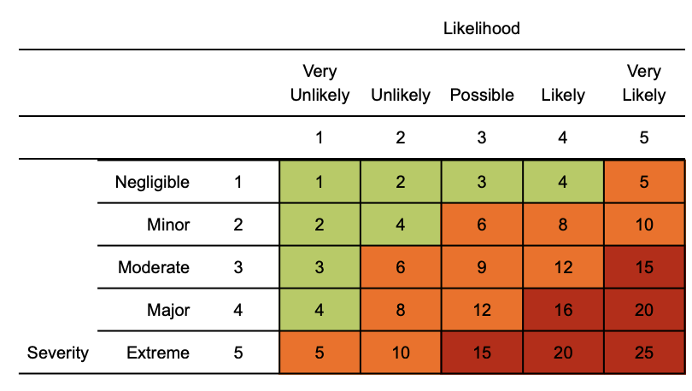
Risk matrix used in risk assessment below
RR = residual risk

Use guidance from the government Plan to Rebuild strategy, Public Health England (PHE), Department of Health & Social Care (DHSC), Health & Safety Executive (HSE) and NHS to ensure the risk assessment is following the latest advice.

Coronavirus (COVID-19) Studio risk assessment

Contents:
Exposure risk
Travel
Access & egress
Welfare / Hygiene
Social distancing (2m and working within 2m of Others)
Manual Handling
First aid

Assessment date: June 2020
Review date: July 2020
Version: 1.0

Hazard | Risk | Control measures | RR | Persons at risk
Exposure from others due to:  1) Living with someone with a confirmed case of COVID-19.  2) Have come into close contact (within 2 metres for 15 minutes or more) with a confirmed case of COVID-19.  3) Being advised by a public health agency that contact with a diagnosed case has occurred. | 4  x  3  =  12 | - Continue following government action of self isolation and only to leave house on the following circumstances: for medical reasons; to shop for necessary food supplies; for exercise;; and for work where you cannot do this at home  - Any existing individual risk assessments (disability, young persons or new / expectant mothers) to be reviewed  - Maintain contact with management and to follow company policy / guidance.  - Travel is only required where you cannot work from home. Use private transportation, cycle or walk. As a last resort public transport to be used as a minimum and to implement social distancing where possible  - To continue following ongoing government guidance  - Stay at home and only attend hospital in an emergency. Do not attend GP surgery and phone NHS line (111) if further advice is required  - Company to ensure extremely clinically vulnerable persons do not come to work and continue to shield themselves whilst following their specific medical advice issued to them  - Follow good NHS hygiene measures at all times  - Avoid all visitors to your home unless they are providing a medical requirement  - Do not approach delivery staff, allow packages to be left on the doorstep  - Do not take any antibiotics as they do not work against viruses. | 4  x  1  =  4 | Staff and Customers
Suspected case whilst in the Studio | 4  x  4  =  16 | If someone develops a high temperature or a persistent cough while in the studio, they should:  - Return home immediately  - Avoid touching anything  - Cough or sneeze into a tissue and put it in a bin, or if they do not have tissues, cough and sneeze into the crook of their elbow.  - They must then follow the guidance on self-isolation and not return to the studio until their period of self-isolation has been completed.  - The Studio area of contact should receive deep cleaning and social distancing maintained | 4  x  1  =  4 | Staff and Customers
General travel including foreign travel | 4  x  4  =  16 | - Do not travel unless you cannot work from home or deemed a key worker – implement teleconferencing for meetings  - Where an individual has recently travelled abroad, they must self isolate for 14 days  - Please continue to follow any further national government advice provided  - Where an occupational health (OH) service provider has been appointed, please seek additional advice or concerns through this service  - All persons to limit their use of public transport. Where travel is essential, please use private single occupancy where possible, cycle or walk | 4  x  1  =  4 | Staff and Customers
Access / egress to the studio | 4  x  4  =  16 | Where possible, please consider and implement the following practices:  - Ensure all extremely clinically vulnerable persons do not attend the studio  - Stop all non-essential visitors  - All class/lesson registration in advance and payment  - Introduce staggered start and finish times to reduce congestion and contact at all times  - Monitor studio access points to enable social distancing, Traffic light system and either increase to reduce congestion or decrease to enable monitoring  - Remove or disable entry systems that require skin contact e.g. door/buttons automatic and look to increase cleaning or removal of common ‘touch points’  - Require everyone to wash or clean their hands before entering or leaving the studio  - Allow plenty of space (two metres) between people waiting to enter site with the one way system  - Regularly clean common contact surfaces in reception, studios, access control and delivery areas e.g. ipads, printers, screens, telephone handsets, desks, particularly during peak flow times  - Reduce the number of people in attendance to classes and windows and door left open for air flow  - Parents/Guardians should remain in their vehicles and only enter the building for under 6 years collection.  - Designate walking routes and one way systems with signage to help maintain social distancing | 4  x  1  =  4 | Staff and Customers
Inclement weather – cold temperature | 2  x  2  =  4 | - All persons to dress appropriately for the weather for queing outside  - Welfare facilities provided to shelter from the elements  - Maintain good hygiene measures at all times  - PPE on individual issue basis and not to be shared | 2  x  1  =  2 | Customers
Poor hygiene | 4  x  4  =  16 | - Wash your hands thoroughly and regularly. Use soap and water for at least 20 seconds. Use alcohol-based hand sanitiser if soap and water is not available and hand washing technique to be adopted as directed by NHS  - Avoid touching your face/eyes/nose/mouth with unwashed hands and cover your cough or sneeze with a tissue then throw it in the bin.  - Provide additional hand washing facilities to the usual welfare facilities if a large spread out site or significant numbers of personnel on site  - Regularly clean the hand washing facilities and check soap and sanitiser levels  - Provide suitable and sufficient rubbish bins for hand towels with regular removal and disposal.  - Studios will need extra supplies of soap, hand sanitiser and paper towels and these should be securely stored.  - Restrict the number of people using toilet facilities at any one time e.g. use a welfare attendant Wash hands before and after using the facilities Enhance the cleaning regimes for toilet facilities particularly door handles, locks and the toilet flush. Disabled toilet used for entry hand cleaning along with sanitisers | 4  x  1  =  4 | Staff/Customers
Food and Drink in the studio | 4  x  4  =  16 | - The customers can stay on site once they have entered and not bring food and drinks into the studio  - Removal of bins and reduced food waste and contamination  - Break times for staff should be staggered to reduce congestion in kitchen and contact at all times  - Hand cleaning facilities or hand sanitiser should be available at the entrance of any main entrance and less touch.  - The staff should be asked to bring pre-prepared meals and refillable drinking bottles from home  - Staff should sit 2 metres apart from each other whilst eating and avoid all contact  - Drinking water should be provided with enhanced cleaning measures of the tap mechanism introduced  - Tables should be cleaned between each use  - All rubbish should be put straight in the bin and not left for someone else to clear up  - All areas used for eating must be thoroughly cleaned at the end of each break and shift, including chairs, door handles and payment devices. | 4  x  1  =  4 | Staff/Customers
Use of Changing facilities | 4  x  4  =  16 | - Introduce staggered start and finish times to reduce congestion and contact at all times  - Introduce enhanced cleaning of all facilities throughout the day and at the end of each day  - Consider decreasing the number or size of facilities available on site if possible  - Based on the size of each facility, determine how many people can use it at any one time to maintain a distance of two metres  - Provide suitable and sufficient rubbish bins in these areas with regular removal and disposal. | 4  x  1  =  4 | Staff/Customers
Manual handling - dual lifting | 4x4 = 16 | - Always consider if the task can be performed with one person using mechanical aid  - Ensure the individual(s) are fit for work prior to commencing task  - Break down the load where possible so that one person can comfortably carry  - Assess your route so you can maintain 2m social distance whilst moving the load  - Where dual lifts cannot be avoided, lift facing away from each each or side by side rather than face to face where possible  - Where PPE is to be used, this is on an individual issue and items should not be shared | 1x4 = 4 | Staff
Taking / accepting deliveries | 4x4 = 16 | - Review logistics plans to ensure safest routes have been identified including implementing one way systems  - Maintain 2m social distancing when accepting delivers  - Review work programme to assess whether deliveries are necessary  - Hand washing and sanitizer measures available to maintain good hygiene | 4x1 = 4 | Staff
Working within 2 metres | 4  x  4  =  16 | - Always consider if the number of people in the studio and can lesson be performed differently without having to breach the 2m social distancing rule  - Staff and Customers are to limit face to face working and physical contact work facing away from each other when possible  - Limit the frequency of working within 2m to an absolute minimum and ensure it is for strictly low intensity, sporadic dances where exposure to this distance is less than 15 mins  - Consider introducing an enhanced authorisation process (permit to contact) for customers where less than 2m distance is accepted  - Provide additional supervision to monitor distancing  - Continue to conduct dynamic risk assessments whilst completing the lessons and speak up if there is a safer way of working  - All equipment to be thoroughly cleaned prior and after using it.  - Increased ventilation will be provided within enclosed spaces  - Studio can consider face covering however, it is advised to speak to a director on these matters and supplies should be reserved for staff as it has been documented that the protective effect is minimal.  - Consideration given to disposable gloves  - Reusable PPE should be thoroughly cleaned after use and not shared between staff. These should be stored in suitable places  - Single use PPE should be disposed of so that it cannot be reused and to control potential contamination is controlled (waste removed)  - Staff deemed clinically vulnerable should never work within 2m of persons and preference should be given to whether any change in lessons can allow an individual to work from a safer distance where possible | 4  x  2  =  8 | Staff/Customers
First aid - including mental health | 4x4 = 16 | - First aid contents to be monitored to ensure adequate supplies remain  - First aid and cover arrangements to be reviewed  - First aider certificates to be checked for validity and understand amended practices in regards to attending a casualty during COVID (such as revised CPR methodology)  - Emergency plans on site and communicated so all staff understand what action to take in the event of a suspected or confirmed case of COVID 19  - Mental health first aiders to be considered  - Effective reporting system established at the studio in order to rectify any raised issues or incidents in a timely manner | 4x1 = 4 | Staff/Customers

Background
Please ensure you understand specific process / procedures as per government guidance
https://www.nhs.uk/conditions/coronavirus-covid-19/
https://www.nhs.uk/conditions/coronavirus-covid-19/self-isolation-advice/
https://www.nhs.uk/conditions/coronavirus-covid-19/advice-for-travellers/
https://www.gov.uk/government/publications/coronavirus-action-plan

Management
- Please ensure all staff are aware of reporting requirements and that all confirmed cases are escalated to Directors.
- Information notes are to be sent out and any updates communicated in a timely manner to everyone.
- This must include letting staff know about symptoms and actions the medical professionals are advising people to take.
- A colleague who has been isolated for 14 days cannot return to work until the appropriate ‘fit note’ documentation is provided by their GP/healthcare provider to demonstrate they are now fit to return to work.
- Assessments to be reviewed every 6 months or where significant change has occurred
- Please remind staff that in order to minimise the risk of spread of infection, we rely on everyone in the industry taking responsibility for their actions and behaviours.
- Please encourage an open and collaborative approach between everyone on site where any issues can be openly discussed and addressed.

If in England call NHS on 111, where you will be assessed by an appropriate specialist. NHS guidance is that you do not go directly to your GP surgery, community pharmacy or hospital unless an emergency occurs

